# Open Flightline Mini Toolset

### Important Notes

The Open Flightline Mini toolbox tools must be run from the Project Map or a saved map from within the Project Folder. The reason is that each of the tools uses QgsProject.instance().absolutePath() to find and read from the project_config.json file.

Quite a few layers have a field that deems the feature active/inactive. This allows certain features to be turned on and off during an aerial operation.

## Setting up Project

### Running “1. Setup Aerial Project” toolbox tool

1. Create a folder that will be the location for the aerial operation, this will be called the “Project Folder”.
2. Open up one of the QGIS Flightline Mini Project Templates from the QGIS/Templates folder from the Repo.
3. Save the Map Project to your Project Folder, this map will be called your “Project Map”.
4. In the “Processing Toolbox”, navigate to “Scripts” then to “Open Flightline Mini”. In here are all the tools relating to Open Flightline Mini toolbox.
5. Run the “1. Setup Aerial Project” tool and fill in the fields:  
   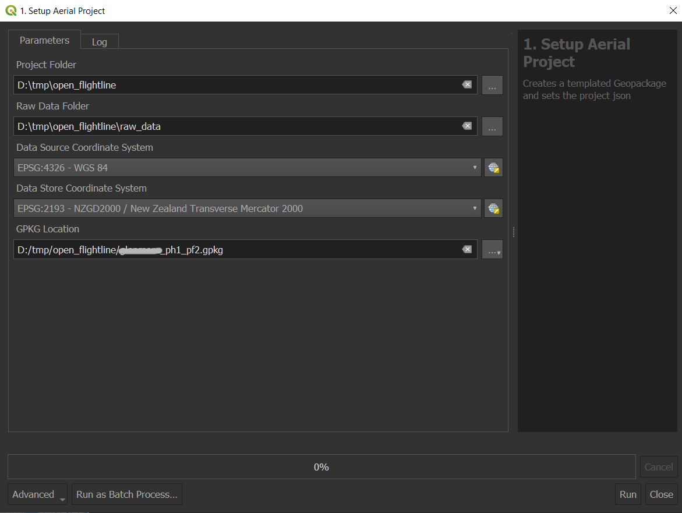  
   - Project Folder = the location of your Project Folder from step 1.  
   - Raw Data Folder = the location where the tool will store the Tracmap data downloads.  
   - Data Source Coordinate System = The CRS that the tracmap system is exporting in.  
   - Data Store Coordinate System = The CRS that your project will use, typically “EPSG:2193…”  
   - GPKG Location = The location of your Project Geopackage where the flight data will be stored.

#### Results

This tool will create an empty templated Geopackage with all of the required tables and layers. It also creates a “project_config.json” that stores your project settings, when other tools get run they look at this json file to pre populate fields or variables about the project.

### Setting up Project Specific Data

1. Create the load sites polygons, to do this start an editing session on the “load_sites” layer and draw a polygon around the load site/s:  
   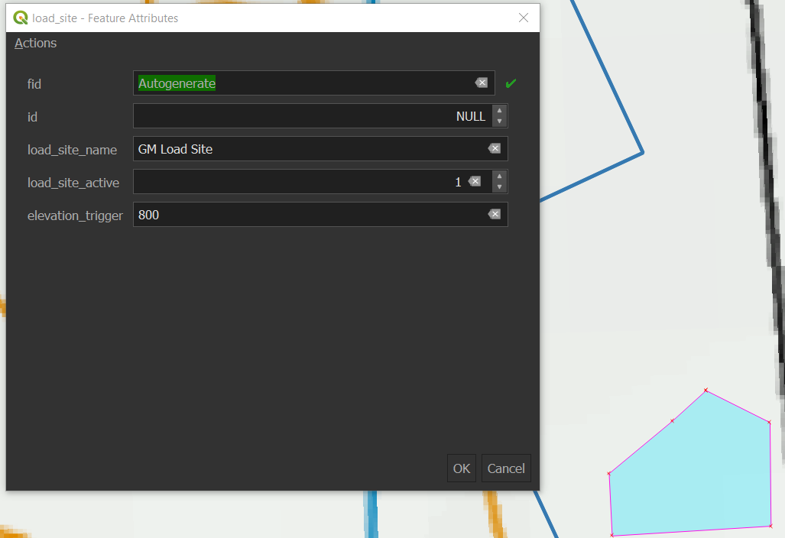  
   load_site_name = unique name for the load site.  
   load_site_active = 0 or 1, this allows a load site to be turned off during an operation.  
   elevation_trigger = the elevation at which the tool will deem a helicopter entering the load site. Typically the ground elevation plus 40m. This allows a helicopter to sow over a load site and not have the tool calculate a new load number.
2. Add the Consent, Corridor and Exclusion shapes to the project, setting the “…_active” field to 0 or 1 allows the feature to be enabled/disabled in any analysis.
3. Create the helicopter and pilot records for the current aerial project, start an editing session on the “heli_info” table and create new records with the machine and pilot details:  
   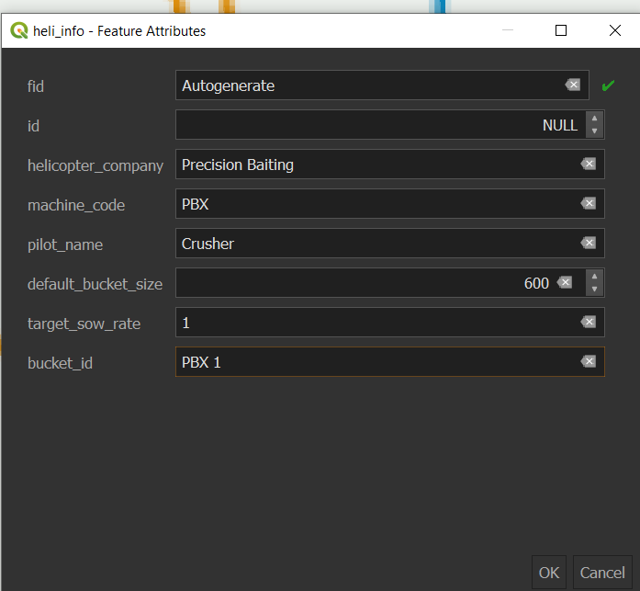  
   *The target_sow_rate is what gets used to calculate the target speed in the load_summary table. The default_bucket_size gets used to calculate the coverage rates when data is loaded in. To change the bucket size for a load, use the “5. Combine and Change Loads” tool.*

## Project Administration

### Running the “2. Backup Aerial Project” toolbox tool

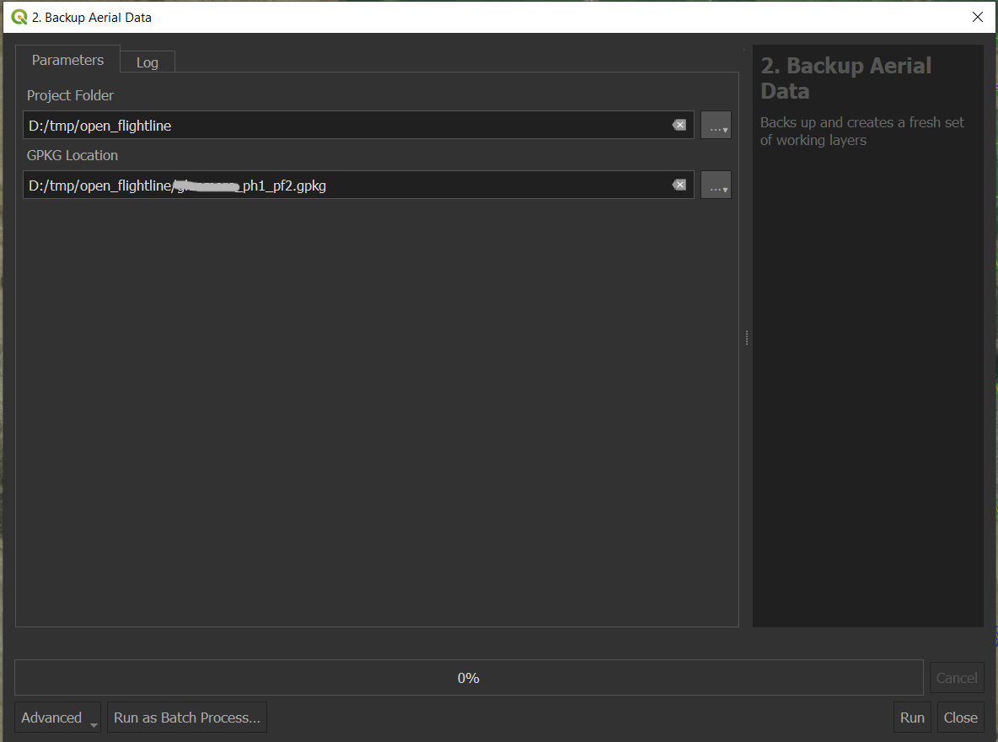

The tool should read from the project_config.json file and pre populate the fields, you can change this if you want to change a different open flight line project.

#### Results

Each of the working layers in the project geopackage will have a sequential number placed at the end of them, the largest number is the most recent backup. Static layers are untouched (load_site, heli_info etc..)

### Running the “3. Cleanup Project Layers” toolbox tool

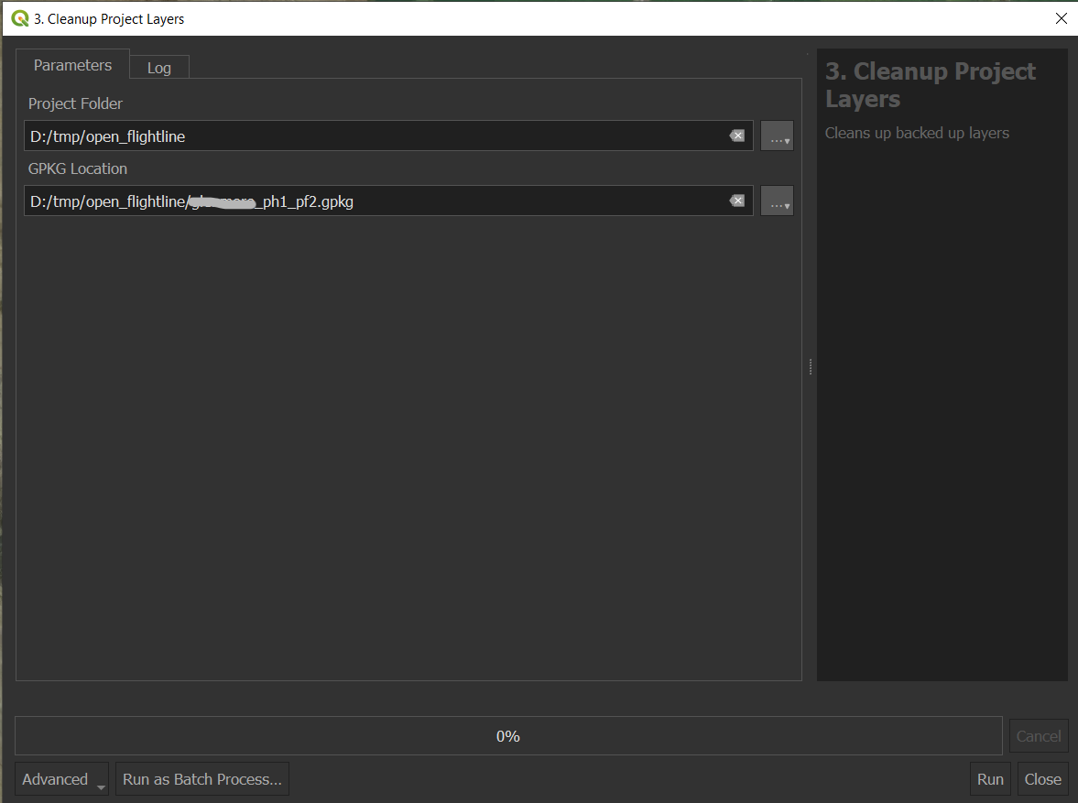

The tool should read from the project_config.json file and pre populate the fields, you can change this if you want to change a different open flight line project.

#### Results

Any of the backed up layers (layers with a number on the end) in the project geopackage will be deleted.

## Project Data and Processing

### Running the “4. Copy Tracmap Data USB” toolbox tool

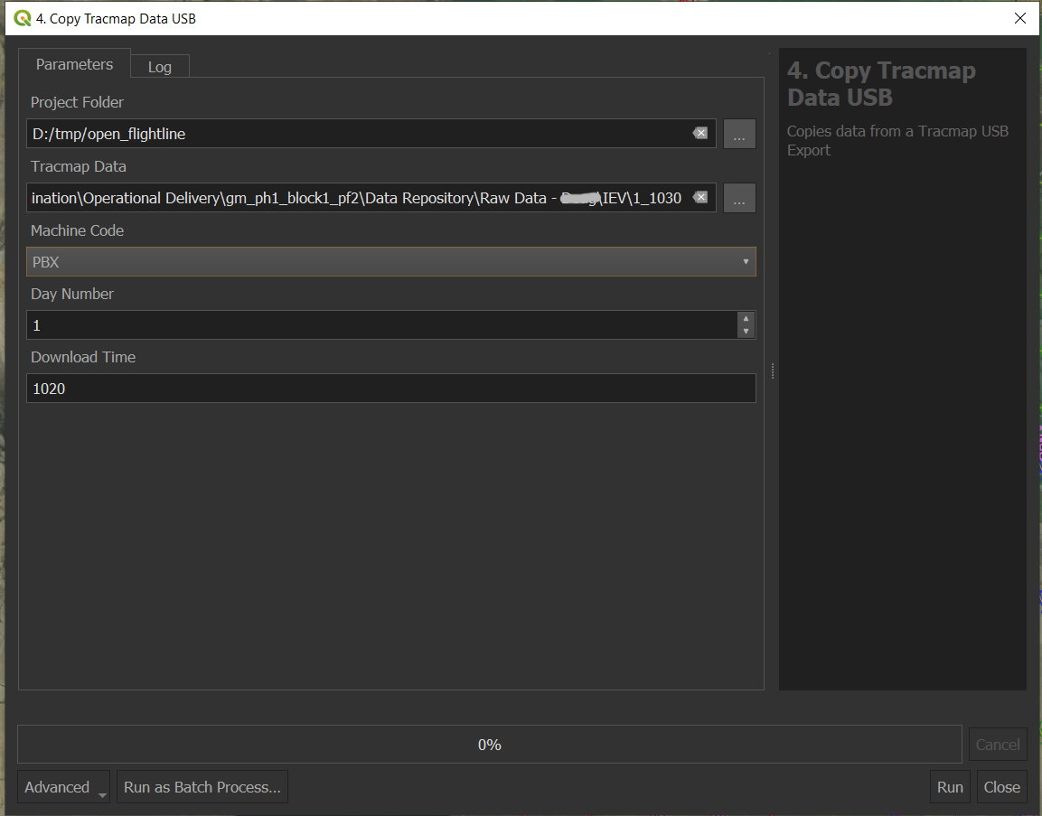

The tool will pick up settings from the project_config.json and will pre populate many of the fields  
Project_folder = The project folder for the aerial operation, this can be changed to another project if needed.  
Tracmap Data = The location of an export of Tracmap data  
Machine Code = The machine code the data came from, this list is populated from the heli_info table.  
Day Number = The day number of the operation, defaults to 1 or what was used previously.  
Download Time = Defaults to the current time, if that time is already in use then the tool will increment the time till it is unique.

#### Resutls

The tool copies the Tracmap Data into the machine code folder within the raw_data folder for the project. It will create a new folder named after the Day Number and Download Time, this then makes up the batch_id that is seen through out the project layers (batch_id = ‘xyz_1_1020’)

### Running the “5. Combine and Change Loads” toolbox tool

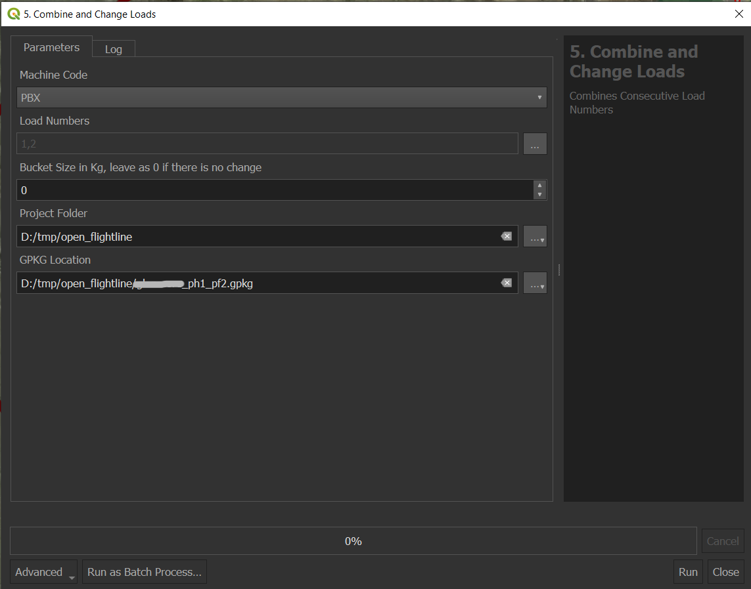

Machine Code = The machine that the change will be applied too  
Load Numbers = The selection of loads to combine, if only one load is selected then just the load size will be updated.  
Bucket Size = The size of the bucket in Kg, if left to 0 then the default bucket size from the heli_info table will be used.  
Project Folder = This is retrieved from the project_config.json but can be changed to another project.  
GPKG Location = This is retrieved from the project_config.json but can be changed to another project.

#### Result

For the selected machine, the load numbers and load size are combined and/or changed. The load_summary, heli_bait_lines and heli_bait_lines detailed layers have data for that load removed and recalculated.

#### Notes

The QGIS processing framework does not allow a field to change based on a previous field input. So there may be more load numbers than a machine has flown, the tool will check that the load numbers exist for that machine and stop running if they don’t.

### Running the “6. Recalculate Machine Data” toolbox tool

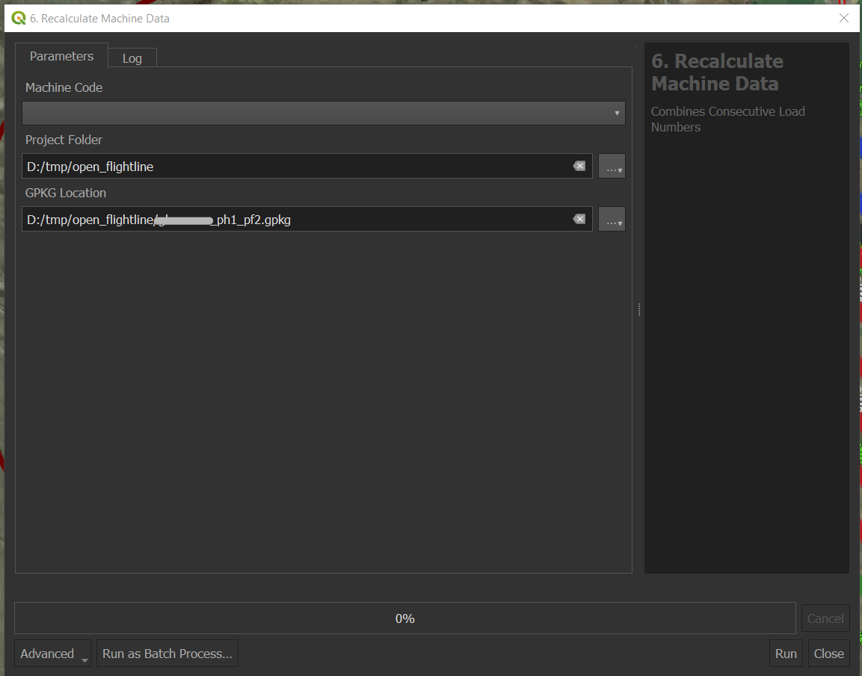

Machine Code = Machine code to recalculate data for.  
Project Folder = This is retrieved from the project_config.json but can be changed to another project.  
GPKG Location = This is retrieved from the project_config.json but can be changed to another project.

#### Results

Recalculates the load_number column in the heli_points layer then deletes data out of the load_summary, heli_bait_lines and heli_bait_lines_detailed layers and recalculates.

#### Notes

This allows a user to edit the raw heli_points data if it has an incorrect elevation, time, location etc.. Any loads that had been combined or had their load size changed will be reset too.

### Running the “7. Delete Data Batches” toolbox tool

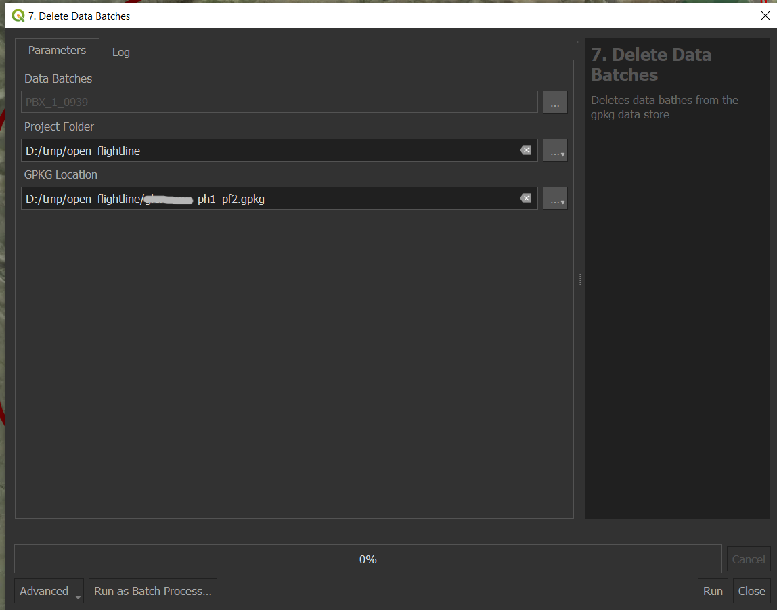

Data Batches = Select the data batches to be deleted. A data batch id is made up of the machine code, day number and download time.  
Project Folder = This is retrieved from the project_config.json but can be changed to another project.  
GPKG Location = This is retrieved from the project_config.json but can be changed to another project.

#### Resutls

Finds any data loaded in the project gpkg relating to that batch and deletes it. It then recalculates the load_summary, heli_bait_lines and heli_bait_lines_detailed layers and recalculates.

# Configuring QGIS and System

1. Download or clone a copy of the repo from here: <https://github.com/zero-invasive-predators/open-flightline-mini>
2. Open up QGIS and go to the File Menu, then to Settings then to Options.
3. In the Options dialog box, go to the Processing tab.
4. Expand out the Scripts Setting and click the three dots to edit the Value
5. Add two records that point to the repo directory location and the open_flightline_mini module:  
   example:  
   - C:/Users/Nicholas/Documents/GitHub/open-flightline-mini  
   - C:/Users/Nicholas/Documents/GitHub/open-flightline-mini/open_flightline_mini  
     
   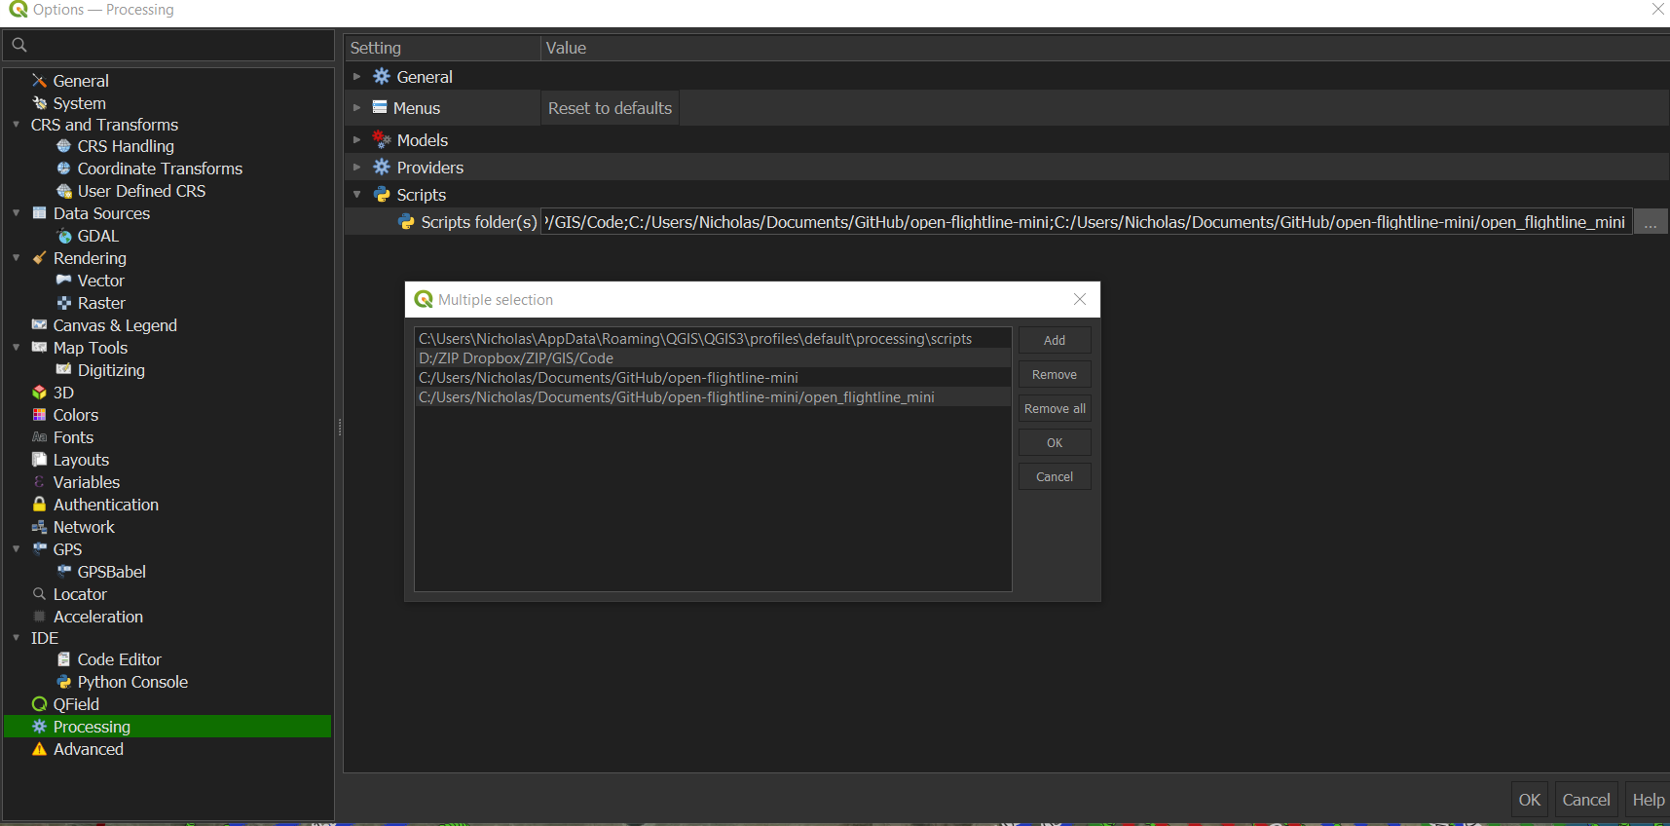
6. Click Ok, and Ok.
7. In the Processing Toolbox under the Scripts section, the Open Flightline Mini tools should appear:

